# SRS Progress Sheet

## Jaswanthi Jagarlamudi

|  |  |
| --- | --- |
| 04-24-23 | 1.Updated System Features 5   * Addition Practice screen   1. Description and Priorities  2. Stimulus/Response  3. Functional Requirements  2.Updated Software Quality Attributes |
| 04-17-23 | 1.Updated other requirements   * Storage solution * Design * Task * Cohesiveness |
| 04-10-23 | 1.Updated Reward Screen  2.Updated Other Non-Functional Requirements   * Performance Requirements * Safety Requirements |
| 04-03-23 | 1.Updated System Features 4   * Adding Puzzle screen   1. Description and Priorities  2. Stimulus/Response  3. Functional Requirements  2.Updated UML class, sequence diagrams |
| 03-20-23 | 1.Added Adding quiz screen  2.Updated System Features 3   * Adding quiz screen   1. Description and Priorities  2. Stimulus/Response  3. Functional Requirements  2.Updated UML class, sequence diagrams |
| 03-13-23 | 1.Updated System Features 2   * Generate random numbers and validate the answers   1. Description and Priorities  2. Stimulus/Response  3. Functional Requirements  2.Updated UML class, sequence diagrams |
| 03-06-23 | 1.Updated System Features 1   * Title / Menu Screen   1. Description and Priorities  2. Stimulus/Response  3. Functional Requirements  2.Updated UML class, sequence diagrams |
| 02-27-23 | 1.Updated Hardware interfaces required  2.Updated Performance requirements  3.Updated class, sequence diagrams |
| 02-20-23 | 1.Updated Overall Description  2.Added Appendix B: Analysis models   1. UML Use case diagram 2. UML Class diagram 3. UML Sequence diagram   3.Added Initial Screen, Home Screen, Puzzle Screen, Store Screen to the user interface |
| 02-13-23 | 1.Updated Introduction   * Purpose * Intended audience and reading suggestions * Product scope   2.Updated external interface requirements   * User Interfaces * Software Interfaces |
| 02-06-23 | 1.Created initial version of document  2.Updated SRS with Table of Contents |

Software Requirements Specification

for

Kid Math Game with cat

**Version 2.0**

**Prepared by Team 1 of Software Engineering Class**

**California State University, San Bernardino**

**04-24-23**

***Copyright © 1999 by Karl E. Wiegers. Permission is granted to use, modify, and distribute this document***

**Table of Contents**

**Table of Contents ii**

**Revision History ii**

**1. Introduction 1**

1.1 Purpose 1

1.2 Document Conventions 1

1.3 Intended Audience and Reading Suggestions 1

1.4 Product Scope 1

1.5 References 1

**2. Overall Description 2**

2.1 Product Perspective 2

2.2 Product Functions 2

2.3 User Classes and Characteristics 2

2.4 Operating Environment 2

2.5 Design and Implementation Constraints 2

2.6 User Documentation 2

2.7 Assumptions and Dependencies 3

**3. External Interface Requirements 3**

3.1 User Interfaces 4

3.1.1 Main Screen 4

3.1.2 Adding Puzzle Screen 4

3.1.3 Adding Fun Screen 5

3.1.4 Adding Quiz Screen 5

3.1.5 Addition Practice Screen 5

3.1.6 Reward Screen 5

3.2 Hardware Interfaces 5

3.3 Software Interfaces 5

3.4Communications Interfaces 5

**4. System Features 5**

4.1 Title/Menu Screen 6

4.1.1 Description and Priorities 6

4.1.2 Stimulus/Response 6

4.1.3 Functional Requirements 7

4.2 Generate random numbers and validate the answers 7

4.2.1 Description and Priority 7

4.2.2 Stimulus/Response 8

4.2.3 Functional Requirements 8

4.3 Adding Quiz Screen 8

4.3.1 Description and Priority 9

4.3.2 Stimulus/Response 9

4.3.3 Functional Requirements 9

4.4 Adding Puzzle Screen 9

4.4.1 Description and Priority 9

4.2.2 Stimulus/Response 9

4.3.3 Functional Requirements 10

4.5 Addition Practice Screen 10

4.5.1 Description and Priority 10

4.5.2 Stimulus/Response 11

4.5.3 Functional Requirements 11

**5. Other Nonfunctional Requirements 11**

5.1 Performance Requirements 11

5.2 Safety Requirements 11

5.3 Security Requirements 11

5.4 Software Quality Attributes 11

5.5 Business Rules 12

**6. Other Requirements**

6.1 Storage solution 12

6.2 Design 12

6.3 Task 12

6.4 Cohesiveness 12

**Appendix A: Glossary 13**

**Appendix B: Analysis Models 14**

1. UML Use Case Diagram 15
2. UML Class Diagram 16
3. UML Sequence Diagram 17

**Appendix C: To Be Determined List**

**Revision History**

|  |  |  |  |
| --- | --- | --- | --- |
| **Name** | **Date** | **Reason For Changes** | **Version** |
| Jaswanthi Jagarlamudi | 02-06-23 | 1.Created initial version of document 2.Updated SRS with Table of contents | 1.0 |
| Jaswanthi Jagarlamudi | 02-13-23 | 1.Updated Introduction   * Purpose * Intended Audience and Reading Suggestions * Product Scope   2.Updated External Interface Requirements   * User Interfaces * Software Interfaces  1. Unity 2. Visual Studio 3. C# and .NET | 1.1 |
| Jaswanthi Jagarlamudi | 02-20-23 | 1.Updated Overall Description   * Product Perspective * Product Functions * User classes and characteristics * Operating Environment   2.Added Appendix B: Analysis Models   1. UML Use Case Diagram 2. UML Class Diagram 3. UML Sequence Diagram   3.Added Initial Screen, Home Screen, Puzzle Screen, Store Screen to the user interface | 1.2 |
| Jaswanthi Jagarlamudi | 02-27-23 | 1.Updated Hardware interfaces required  2.Updated Performance requirements  3.Updated class, sequence diagrams | 1.3 |
| Jaswanthi Jagarlamudi | 03-06-23 | 1.Updated System Features 1   * Title / Menu Screen   1. Description and Priorities  2. Stimulus/Response  3. Functional Requirements  2.Updated UML class, sequence diagrams | 1.4 |
| Jaswanthi Jagarlamudi | 03-13-23 | 1.Updated System Features 2   * Generate random numbers and validate the answers   1. Description and Priorities  2. Stimulus/Response  3. Functional Requirements  2.Updated UML class, sequence diagrams | 1.5 |
| Jaswanthi Jagarlamudi | 03-20-23 | 1.Added Adding quiz screen  2.Updated System Features 3   * Adding Quiz screen   1. Description and Priorities  2. Stimulus/Response  3. Functional Requirements  3.Updated UML class, sequence diagrams | 1.6 |
| Jaswanthi  Jagarlamudi | 04-03-23 | 1.Updated System Features 4   * Adding Puzzle screen   1. Description and Priorities  2. Stimulus/Response  3. Functional Requirements  2.Updated UML class, sequence diagrams | 1.7 |
| Jaswanthi  Jagarlamudi | 04-10-23 | 1.Updated Reward Screen  2.Updated Other Non-Functional Requirements   * Performance Requirements * Safety Requirements | 1.8 |
| Jaswanthi Jagarlamudi | 04-17-23 | 1.Updated other requirements.   * Storage solution * Design * Task * Cohesiveness | 1.9 |
| Jaswanthi Jagarlamudi | 04-24-23 | 1.Updated System Features 5   * Addition Practice screen   1. Description and Priorities  2. Stimulus/Response  3. Functional Requirements  2.Updated Software Quality Attributes | 2.0 |

# Introduction

## 1.1 Purpose

The game application “Kid Math Game with Cat” is an attractive, interactive, and entertaining game. This game is created on the Unity Hub tool. Kids can enhance their mathematical skills by playing this game for fun. It provides learning in counting, addition methods. This game provides a challenging and engaging educational experience for kids.

## 1.2 Document Conventions

The document was developed using the IEEE’s Software Requirement Specification.

## 1.3 Intended Audience and Reading Suggestions

The Software Requirement Specification provides the way for the user to verify that the game developed is coordinated with the original idea.To completely understand and review the project from initial stage to developed, the content was created in portions and can be therefore read such as described.To have a general overview of the project, view the description Part 2.For a detailed explanation of the game play elements and how they connect to the character, see System Features Part 3.If you are excited about the game’s interface and how to use the front-end menus, view External Interface Requirements Part 4.The technical requirements that the project will hold are listed in Nonfunctional Requirements Part 5.

## 1.4 Product Scope

The game “Kid Math Game with cat” aids in teaching kids the counting, addition concepts. The mixed math style makes the concept understandable to players of any skill level. Additionally, this game offers a fun exercise to kids where kids can be able to learn the concept of addition with different items. Hints are also introduced to the users to make them understand the concept and solve the level in a better way.

## 1.5 References

* Software Engineering: A Practitioner’s Approach
* IEEE Template: <https://goo.gl/nsUFwy> for System Requirements Specification documentation
* GitHub page:
* NuGet:<https://www.nuget.org/> package manager designed to enable developers to share reusable code.

### 

# Overall Description

## 2.1 Product Perspective

The game is an identical replica of the original kid math game app that is available in the play store. The primary goal of this game is to make the mathematical concept of addition simpler and more enjoyable for kids to learn. This game provides us with the learning experience.

## 2.2 Product Functions

Adapting kids to learn basic math addition calculations by implementing kid math game for the questions asked based on the difficulty level and thereby pointing towards answers. Implementing high quality cartoon animations wherever necessary for the effectiveness of kid’s learning. The following is a summary of the major features implemented in the game. Based on the necessity of the game to function this is separated into categories.

* Title / Menu Screen : This is the application’s initial viewable screen, which includes buttons for a new player, volume control
* Creating characters with names : Different characters are created with names to help us move from one phase to another phase.
* Adjust questions based on difficulty level : There will be a screen where the game redirects us to the next levels based on our performance from easy to medium and hard.
* Generate questions and validate the answers with reactions: Adding puzzles are generated here and the characters created help us to validate the answers.
* Collecting stamps, stickers and toys : During the game different toys and stickers can be collected while moving to different levels.
* Kid learning progression track: For every game the kid plays, his/her data is recorded, a certificate is generated which tracks the development of his/her performance.

## 2.3 User Classes and Characteristics

The control scheme is designed to be intuitive, and the game play is fair enough to be understood for everyone. Therefore, the experience with the game will not be a major factor in dividing the end users. However, any game has some basic division among its end users as hardcore players and casual players. The hardcore players for this game are obviously kids who are attending their primary school.

## 2.4 Operating Environment

This application will be launched on both play store(Android) and App store(iOS).A web-based platform is not currently intended.

## 2.5 Design and Implementation Constraints

The kid math game is a very minimalistic app both in its functionality and user experience. As of now there are no constraints that are noticed for the developers.

## 2.6 User Documentation

While this app is the simplest and the minimalistic one, end users will not face much difficulty.

While using the app as we have not implemented any complex operations on the app that uses huge compatibility. However, kids who are about to start their learning journey, we will provide them with a tutorial video on how to use the app.

ONLINE HELP:

* A step-by-step tutorial video on how to navigate on the application.

## 2.7 Assumptions and Dependencies

We will use Unity 2D for graphics, after the testing phase, we will decide the minimum requirements and oldest android version to be supported then released on market.As of now we have not noticed any dependencies and assumptions for this application as the application does not have any complex operations and it is a standalone application.

# External Interface Requirements

The interface specifications for the system are described in this section of the SRS. User, hardware, software and communication interface requirements are defined.

## 3.1 User Interfaces

3.1.1 Main Screen

This screen consists of adding puzzles, adding fun, adding quiz, and adding practice buttons where the kid can be redirected to different scenarios according to their choice.

3.1.2 Adding puzzle Screen

This screen consists of solving the puzzles with different numbers and addition operators.

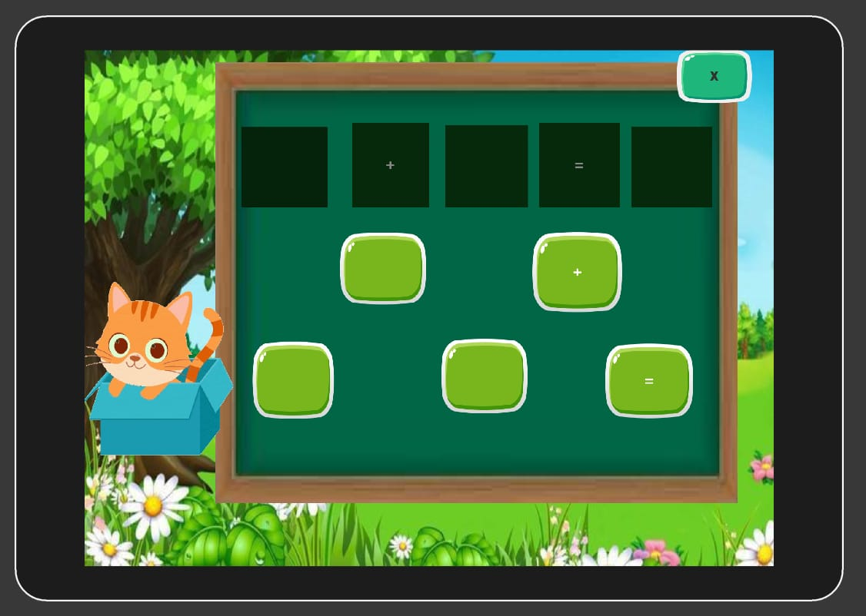

3.1.3 Adding Fun Screen

This screen consists of adding numbers using different entities.

3.1.4 Adding Quiz Screen

This screen consists of additional quiz with different numbers.

3.1.5 Addition Practice Screen

This screen consists of different levels beginner, intermediate and advanced where the kid can be redirected to solve the adding practice examples according to his level of progress.

3.1.6 Reward Screen

Whenever completed an appropriate task congratulations screen will appear and prompts the user to the next continuing step.

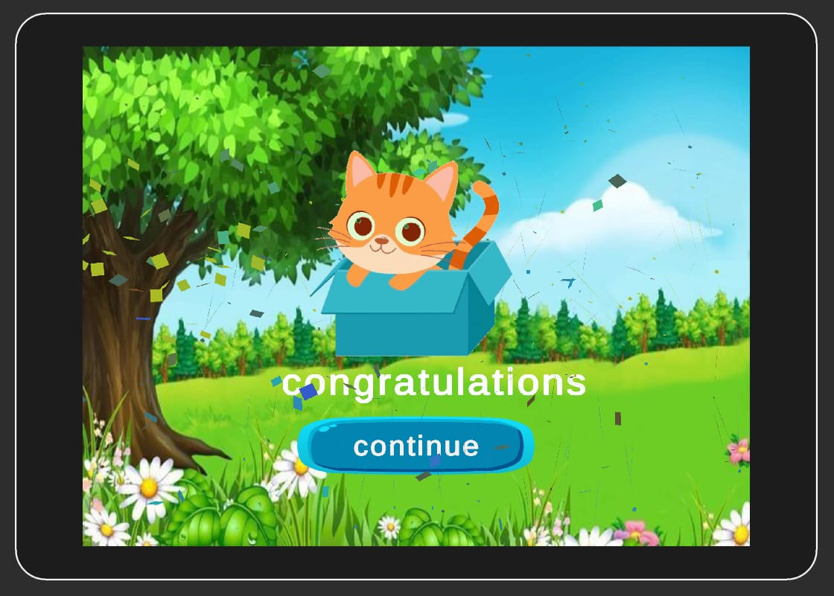

## 3.2 Hardware Interfaces

The minimum hardware requirements of Math Kid game are a 500-Megahertz CPU and 1024 megabytes of RAM. Also, a compatible graphics card is required as Math Kid game uses an OpenGL 2D engine to speed up graph visualization. A system with these specifications can handle a network of approximately 1000 edges and nodes.

## 3.3 Software Interfaces

3.1.1 Unity

* For the project, a 32-bit personal version of the Unity game engine is utilized.
* The program should not require any of the features from the personal edition.
* The user interface of the Connectome application will be powered by Unity game engine. Although the application won’t have any elements for gaming, the framework makes it simple to interact with the kid math game.

3.1.2 Visual Studio

A streamlined code editor, Visual Studio Code supports development activities like task execution, debugging, version management. It seeks to offer only the tools a developer needs for a brief code-build-debug cycle and leaves more complicated processes to IDEs with more features, like Visual Studio IDE

3.1.3 C# and ASP.NET

* C# is the only programming language used across the application’s backend.
* Visual Studio 2015 is used to compile all C# source code# development utilizes the NET framework version 3.5 due to limitations imposed by the Unity game engine.

## 3.4 Communications Interfaces

Since there is no network activity needed, there are no requirements of any interface.

# System Features

## 4.1 Title/Menu Screen

## 4.1.1 Description and Priority

The title screen is the screen the player will see every time upon entering the game. Through this interface, the player can choose to start the game, play the resumed game, or adjust the options. Since the title / menu screen is the “hub" for all activities in the project, it must be included.

## 4.1.2 Stimulus/Response Sequences

Step 1: The player will launch the game from their portable device.

Step 2: The start screen loads and appears prompting the player to start with the

game

Step 3: The player presses the button, triggering to different functionalities of the

game, whether it could be adding puzzle, adding quiz, adding fun and

addition practice.

## 4.1.3 Functional Requirements:

RFQ-1: The title / menu screen must load and appear every time the game is

launched.

RFQ-2: If the player quits the game during any stage of a level, they must be

retired to the main screen.

RFQ-3: If the player presses the exit button, the game will end and return the

player to the mobile’s regular interface.

RFQ-4: If the player completes the game, it will take to the rewards page and

then returns the player to the menu screen.

## 4.2 Generate random numbers and validate the answers

## 4.2.1 Description and Priority :

The player after going to the menu screen navigates to the adding puzzle screen

where questions regarding the addition practice are displayed in the questionnaire

board and here the player must choose an answer and drag the appropriate answer

to the correct place. If the response is accurate, an animation of a cat will appear to

show that it is accurate; otherwise it prompts the player to let them know that it is a

wrong response. If the answer is accurate it moves to the next level.

## 4.2.2 Stimulus/Response Sequences :

Step 1 : The player navigates to the adding puzzle screen from the main menu

screen.

Step 2 : In the adding puzzle screen we can see a questionnaire board and some

random numbers along with accurate number for response.

Step 3 : An addition question will be generated with random numbers and

displayed on the questionnaire board.

Step 4 : In the answer board random numbers are generated to select the correct

answer.

Step 5 : Once the answer is selected from the board, it will either popup a cat

animation if it is correct or displays as incorrect if it is wrong.

## 4.2.3 Functional Requirements :

RFQ-1 : The cat should appear and prompt the answer as correct on the screen if the

player selects the correct answer from the random numbers.

RFQ-2 : When the player chooses the correct answer and drops it in the right place,

a cat animation needs to play.

RFQ-3 : When the player chooses the wrong response, it should prompt as incorrect

answer.

RFQ-4 : By clicking on the home button displayed at the top right corner, the player

can go back to the menu screen and start the game again.

## 4.3 Adding Quiz Screen

## 4.3.1 Description and Priority :

The player after going to the menu screen navigates to the adding quiz screen

where questions regarding the addition practice are displayed in the questionnaire

board and here the player must choose an answer and drag the appropriate answer

to the correct place. If the response is accurate, an animation of a cat will appear to

show that it is accurate; otherwise it prompts the player to let them know that it is a

wrong response. If the answer is accurate it moves to the next level.

## 4.3.2 Stimulus/Response Sequences :

Step 1 : The player navigates to the adding quiz screen from the main menu

screen.

Step 2 : In the adding quiz screen we can see a questionnaire board and some

random numbers along with accurate number for response.

Step 3 : An addition question will be generated with random numbers and

displayed on the questionnaire board.

Step 4 : In the answer board random numbers are generated to select the correct

answer.

Step 5 : Once the answer is selected from the board, it will either popup a cat

animation if it is correct or displays as incorrect if it is wrong.

## 4.3.3 Functional Requirements :

RFQ-1 : The cat should appear and prompt the answer as correct on the screen if the

player selects the correct answer from the random numbers.

RFQ-2: When the player chooses the correct answer and drops it in the right place,

a cat animation needs to play.

RFQ-3: When the player chooses the wrong response, it should prompt as incorrect

answer.

RFQ-4: By clicking on the home button displayed at the top right corner, the player

can go back to the menu screen and start the game again.

## 4.4 Adding Puzzle Screen

## 4.4.1 Description and Priority:

The player after going to the menu screen navigates to the adding puzzle screen by

clicking on the adding puzzle button where some puzzles with numbers, addition

operators and equal to operators regarding the addition practice are displayed in the

questionnaire board and here the player must choose an answer and drag the

appropriate number and operator to the correct place. If the response is accurate, an

animation of a cat will appear to show that it is accurate; otherwise, it prompts the

player to let them know that it is a wrong response. If the answer is accurate it moves

to the next level.

## 4.4.2 Stimulus/Response Sequences:

Step 1: The player navigates to the adding puzzle screen from the main menu

screen.

Step 2: In the adding puzzle screen we can see a questionnaire board and some

random numbers along with addition and equal to operators to complete the puzzle.

Step 3: An addition puzzle will be generated with numbers and addition, equal to

operators and displayed on the questionnaire board.

Step 4: In the answer board random numbers are generated along with + and =

operators to drag them to the correct place to form a perfect addition operation.

Step 5: Once the answer is selected and dropped in an appropriate place from the

board, it will either popup a cat animation if it is correct or displays as incorrect if

it is wrong.

## 4.4.3 Functional Requirements :

RFQ-1: The cat should appear and prompt the answer as correct on the screen if the

player selects and drops the correct number and operator from the generated puzzle.

RFQ-2: When the player chooses the correct answer and drops it in the right place,

a cat animation needs to play.

RFQ-3: When the player chooses the wrong response, it should prompt as incorrect

answer.

RFQ-4: By clicking on the home button displayed at the top right corner, the player

can go back to the menu screen and start the game again.

## 4.5 Addition Practice Screen

## 4.5.1 Description and Priority:

The player after going to the menu screen navigates to the addition practice screen by

clicking on the addition practice button where various puzzles with numbers, addition

operators and equal to operators regarding the addition practice are displayed in the

questionnaire board and here the player must choose an answer and drag the

appropriate number and operator to the correct place. If the response is accurate, an

animation of a cat will appear to show that it is accurate; otherwise, it prompts the

player to let them know that it is a wrong response. If the answer is accurate it moves

to the next level.

## 4.5.2 Stimulus/Response Sequences:

Step 1: The player navigates to the addition practice screen from the main menu

screen.

Step 2: In the addition practice screen we can see a questionnaire board and some

random numbers along with addition and equal to operators to complete the puzzle.

Step 3: An addition puzzle will be generated with numbers and addition, equal to

operators and displayed on the questionnaire board.

Step 4: In the answer board random numbers are generated along with + and =

operators to drag them to the correct place to form a perfect addition operation.

Step 5: Once the answer is selected and dropped in an appropriate place from the

board, it will either popup a cat animation if it is correct or displays as incorrect if

it is wrong.

## 4.5.3 Functional Requirements:

RFQ-1: The cat should appear and prompt the answer as correct on the screen if the

player selects and drops the correct number and operator from the generated puzzle.

RFQ-2: When the player chooses the correct answer and drops it in the right place,

a cat animation needs to play.

RFQ-3: When the player chooses the wrong response, it should prompt as incorrect

answer.

RFQ-4: By clicking on the home button displayed at the top right corner, the player

can go back to the menu screen and start the game again.

# Other Nonfunctional Requirements

## 5.1 Performance Requirements

Considering the capability of modern smartphones and android operating systems, performance shouldn’t be a problem. Phones with lesser hardware, however, can experience certain issues and may operate slowly. No matter the hardware, the game is designed to provide a fun experience on all android phones. The game’s functioning will be simple enough and easy to understand. The graphics won't be extremely complex to avoid slowing down the system.

## 5.2 Safety Requirement

The Kid Math Game with Cat will not interfere with or harm any of the other applications loaded on the player's phone. Additionally, the game won't make the player's phone overheat, protecting the phone's internal parts from harm. To avoid potential harm to the player, the Kid Math Game with Cat should not be played when the player's attention is split between several things.

## 5.3 Security Requirements

Since the Kid Math Game with Cat concept won't request any personal information from the player, it can't possibly compromise such information. This math game can be played without the need for prayer authentication. Simply downloading the application will allow the gamer to begin using addition operations in multiple ways. Therefore, kid’s math game can be played by anybody who has access to a player's phone. Any unauthorized player will be able to play math game if they get their hands on the original player's phone. It is the player's obligation to make sure that no other player or individual can access their phone.

## 5.4 Software Quality Attributes

Kid Math Game concept with cat responds to the player's directions promptly to guarantee dependability and accuracy. The results of a player's action in the game should be visible to other players in milliseconds, not ten seconds afterwards. The Kid Math Game concept with cat is flexible and adaptable, and it will automatically save the player's progress once each level is finished. In this method, if the player's phone runs out of power while they are playing, they can resume the game at a logical beginning point.

The player will find the graphical user interface to be quite easy to use in terms of usability. Kid Math Game concept with cat early levels also gradually introduce all of the different commands that the player has access to, as well as any other game features that the player might need to be familiar with in order to advance. These introductions and pointers won't be provided in more challenging and raised levels because a player will already be familiar with all of the resources required to finish the level. This strategy will guarantee that the user experiences a hard game while also gradually learning all of the game concepts. Our game does not favor either ease of use or ease of learning more than the other. Any player should be able to pick up and start playing the Kid Math Game idea with Cat right away without spending too much time getting used to the controls. The player won't be overwhelmed by needing to utilize every control at once in the early levels because of the controls' simplicity and intuitiveness. As a player advances through the game and completes each level, the gameplay will gradually introduce each command, making it easier for them to learn and use. The player should be fully capable of using the command introduced in every given level, as well as other commands introduced in earlier levels, by the time that level is through.

## Business Rules

# Other Requirements

**Appendix A: Glossary**

## Storage solution

We looked at two potential game data storage systems. Using a file or an integrated database were the options. We chose to utilize Azure App Service as our back-end technology since it offers excellent support for databases and has user-friendly interfaces for getting and storing data. With the class Azure App Service, it provides a simple method to create, edit, and manage Azure App Service. Even if the application were to end abruptly, a database and periodic game data saving will guarantee that no data will be lost.

## Design

The database is created, and the game content is added when the game is installed. The game retrieves the Current game state at the beginning, which includes the Current task and the path. If there is no Current game state, the Current task is set to the first task in the newly retrieved route from the database.

## Task

The user's first user interface screen is a welcome screen with a text greeting and a button for moving on to the next activity. The next job in the route is fetched from the database when the user presses the next task button. When the task is finished, the application automatically retrieves the following one. The welcome page will appear once more after the user departs the game, and the route and task are then pulled from the database. The task that the user was working on when the application was terminated will be loaded if the user clicks the next task button.

## Cohesiveness

High cohesion promotes reusability, reliability, and robustness. Each module, class, and file in the entire project is somehow dependent upon one another because it is a gaming project, so it cannot be finished alone. We would need access to both the real character's location as well as the locations of any colliding objects in order to identify the primary character's collision with any limits, walls, or other obstacles. Because each item in a game must access the information or fields of the other objects in order for the game's physics to function, practically all game code is cohesive, making this project's cohesiveness higher than that of typical software projects.

**Appendix B: Analysis Models**

## UML Use Case Diagram:

Use case diagrams are the diagrams which are used to show the relation between actors and their interactions. A use case diagram shows various use cases and different types of users the system has and will be accompanied by other types of diagrams as well.

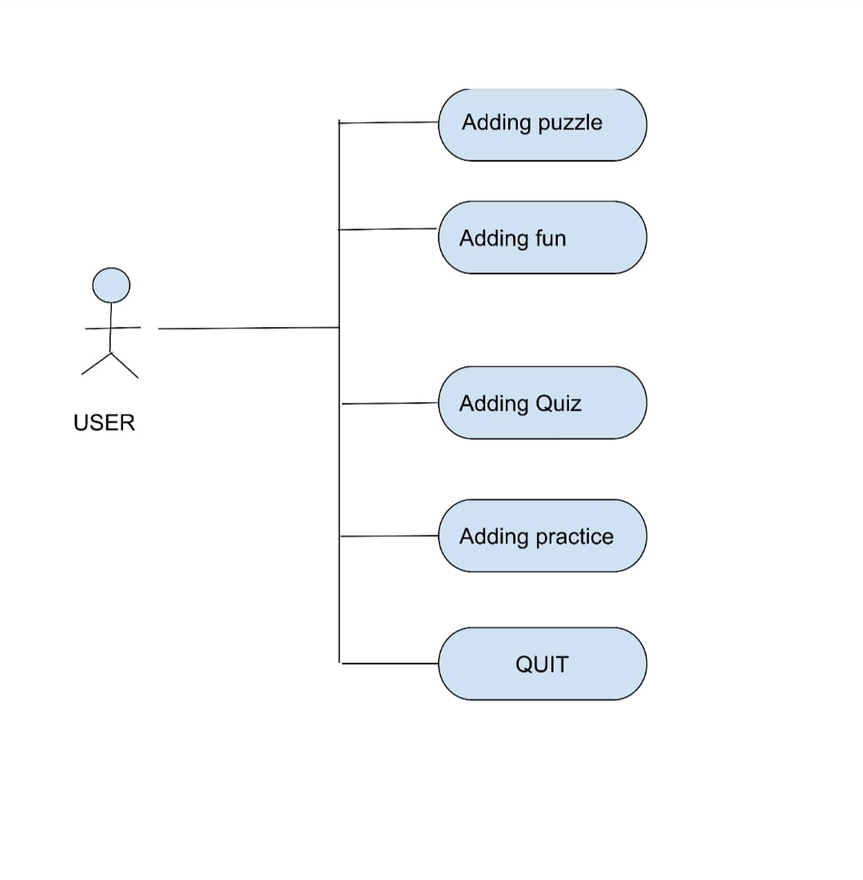

## UML Class Diagram:

UML diagram describes a system by visualizing the different types of objects within a system and the kinds of static relationships that exist among them. It also illustrates the method operations and attributes of the classes.

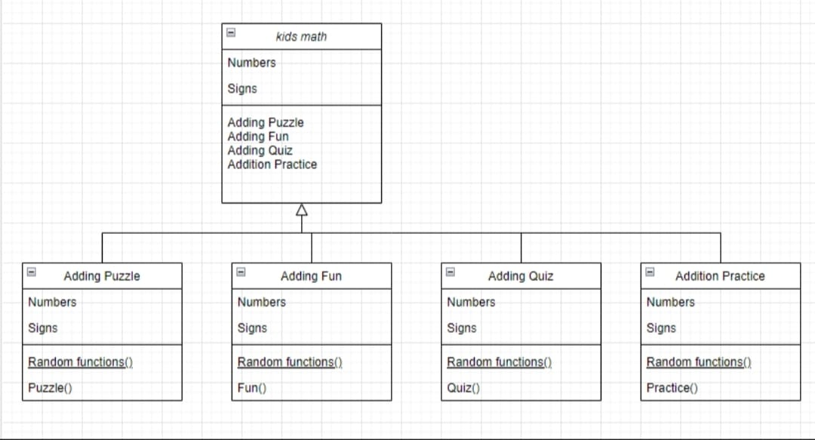

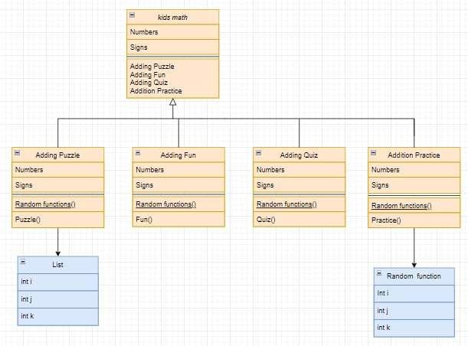

## UML Sequence Diagram

UML Sequence diagram illustrates the sequence of messages between objects in an interaction.A sequence diagram consists of a group of objects that are represented by lifelines, and the messages that they exchange over time during interaction.

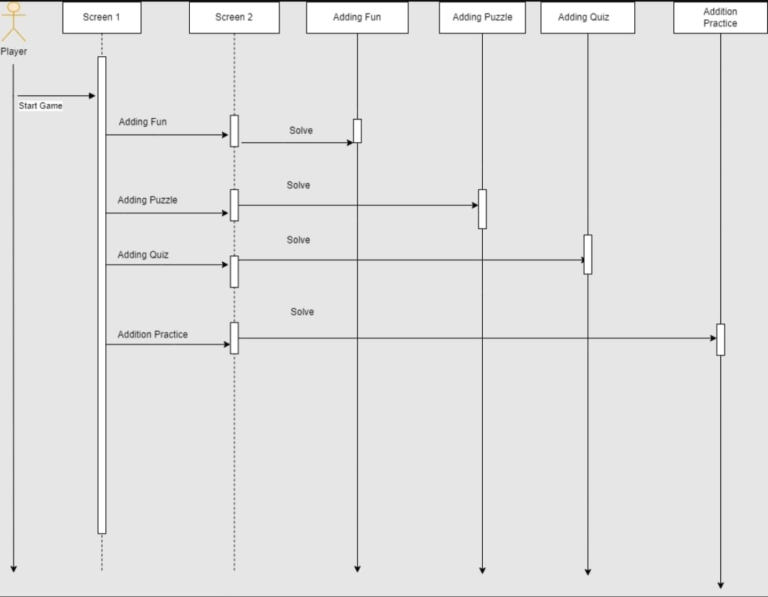

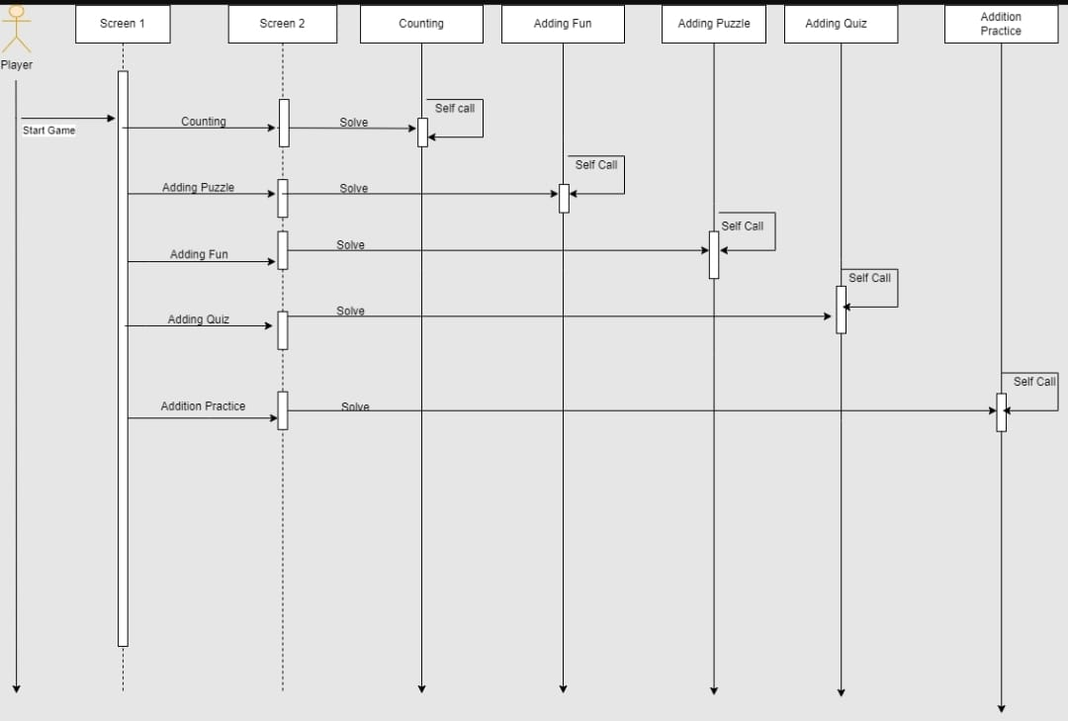

**Appendix C: To Be Determined List**